Have you Planned Ahead?

A few simple steps everyone can take
for peace of mind giving time at a challenge transition in life to focus on relationships

Have you considered an End-of-life Doula?

Legal Medical & Funeral Preferences.

Have you planned your legal choices?

Everyone needs to set out their wishes in advance. When you better understand your choice, then the end of your life can be easier. Make sure family and friends know about your wishes. Ideally copies of this should be stored at home, Doctors office at solicitors, and at your chosen Funeral Directors, and your family should be told where to find them. Place a note on your fridge about where to find them so if an ambulance offer is looking it is easy. Separate this document to 3 separate booklets now!

These can include making legal decisions, and listing names, such as:
Contacts: Primary Next of Kin ____________________________________________________
Phone and email_________________________________________________________

Alternative Next of Kin ________________________________________________
Family important person ______________________________________________
Solicitor__________________________________________________________________
____________________________________________________________________________
Financial Power of Attorney ___________________________________________
____________________________________________________________________________
Medical Power of Attorney ____________________________________________
____________________________________________________________________________
Location of Will _________________________________________________________
____________________________________________________________________________
Location of Medical Wishes Advanced Directive (part of this document)___________________________________________
___________________________________________________________________________
Who holds the Pre-Paid funeral _______________________________________
____________________________________________________________________________
Location of Funeral Arrangements ___________________________________
Social Media Information_______________________________________________

Have you planned the people to notify?

Employer/s _______________________________________________________
Doctor/s _______________________________________________________
_______________________________________________________
Health Professionals _______________________________________________________
(e.g. Dentist, Physiotherapist) _______________________________________________________
_______________________________________________________
Priest _______________________________________________________
Landlord _______________________________________________________
Government
Centrelink (132 850) Medicare (132 011)
Dept Veterans’ Affairs (133 254) ATO (132 861)
Vehicle Rego & Licence (131 171) AEC (voting) (132 326)
Local Council _____________________________________________________
Services
Electricity _______________________________________________________
Gas _______________________________________________________
Telephone / Internet _______________________________________________________
Water _______________________________________________________
Post Office _______________________________________________________
Newsagent _______________________________________________________
Trade Union _______________________________________________________
Clubs & Associations _______________________________________________________
Financial
Bank/Credit Union _______________________________________________________
Superannuation Fund _______________________________________________________
Health Benefits Fund _______________________________________________________
Insurance (life, house, car) _______________________________________________________
Accountant _______________________________________________________
Financial Planner _______________________________________________________
Please turn over to see my online accounts and passwords

Information Required for the Registration of a Death

Full name: _____________________________________________________________________________
Address: ______________________________________________________________________________
Occupation when working: __________________________________________________________
Sex: _____________ Returned Services: ______________
Religion: _____________ Type of Pension: ______________
Date of Birth: _____________ Place of Birth: ______________

Year arrived Australia: _______ State arrived: ______________

Father’s Name: ___________________________________________________________________

Fathers Occupation: __________________________________________________________________

Mother’s Name: __________________________________ (Maiden name): _________________
Mother’s Occupation: ________________________________________________________________

No. of Marriages/Relationships: ________ Present Marital status: ________________

1. Where 2. Where 3. Where
Date Date Date
To Whom To Whom To Whom

Names of children (including deceased children) and dates of birth:

_______________________________________________________________________________

_
Have you Planned your health choices?

A few guidelines (a simple Advanced Care Plan) might your family to make decisions relating to your health preferences. This is sufficient for your wishes to be carried out……but some states and institutions are requesting their documents are completed. Your choice whether you fill them in. All documents are as legally binding unless someone contests them……and even wills are constantly contested and changed.

Choice of Medical Agent/Medical Power of Attorney.
I understand that my medical agent/medical power of attorney will be able to do the following if I am not able to:
- Make medical choices for me.
- Agree or refuse treatment for me.
- Interpret instructions on this form for me.
- Make decisions on when to refuse ongoing treatments/life support.
- Authorise release of my medical records if needed.
- Authorise medications and pain treatments for me.
- Communicate my wishes regarding organ/tissue donations.
(I understand I can revoke this authority at any time.)
The person I want to make medical treatment decisions for me is:
Primary Medical Agent/POA: Name: _______________________________________________
Address: _______________________________________________________________________________
Phone/s _______________________________________________________________________________

Secondary Medical Agent/POA: Name _____________________________________________
Address: _______________________________________________________________________________
Phone/s _______________________________________________________________________________

Signing and witnessing this double page forms an Advanced Care Plan
Signature: ___________________________ Date: ___________________________
Witness: ___________________________ Date: ___________________________
Witness: ___________________________ Date: ___________________________
The Kind of Medical Treatment I want/don’t want.

I am open to the idea of Death with Dignity (Euthanasia) when it is legal
https://www.dwdv.org.au/ read this so you understand.

If life support treatment will only delay my death, I:
1. Want to have Life Support. ☐
2. Do not want to have Life Support. ☐
3. Want to delegate decisions to my Medical Agent. ☐

If I am in a coma and not expected to wake up or recover, I:
1. Want to have Life Support. ☐
2. Do not want to have Life Support. ☐
3. Want to delegate decisions to my Medical Agent. ☐

If I have permanent and irreversible brain damage and am not expected to wake up or recover, I:
1. Want to have Life Support. ☐
2. Do not want to have Life Support. ☐
3. Want to delegate decisions to my Medical Agent. ☐

Any other conditions under which I do not wish to be kept alive:

Use of Pain killing and comfort drugs____________________________________ Yes please ☐

Keep me totally comfortable even if it shortens my life ☐

Awake as much as possible_______________________________________________ ☐

If I choose to withdraw from food and water, please let me ☐

Please let me die in my own time without pushing me to live ☐

These decisions can be formalized by filling out a Refusal of Treatment certificate, which may be obtained from your GP. Not necessary but some people feel more comfortable filling in a formal form…. give a copy of this to your GP
Location of Refusal of Treatment Certificate: ___________________________________________________

Other wishes, need and wants
How I want people to treat me during illness.

If life support treatment will only delay my death, I:
Yes No
1. Medical treatment discussions in my room? ☐ ☐
2. Medical treatment discussions with family present? ☐ ☐
3. Medical treatment discussions only with my medical agent? ☐ ☐
4. I want to have people present at in my last hours? ☐ ☐

Particular people I would like present: ____________________________________________ __________________________________________________________________________________________
Particular people I would welcome visits from (priests, colleagues, etc.): __________________________________________________________________________________________
__________________________________________________________________________________________
People I would like to exclude please_______________________________________________
If it can be done, I want to die at:
1. My Home. ☐
2. Palliative Care/Hospice. ☐
3. Age Care Facility/Nursing Home. ☐
4. Hospital. ☐
5. Not important to me. ☐
My other Preferences:
Organ/Medical Donations: _______________________________________________________
__________________________________________________________________________________________
__________________________________________________________________________________________
Arrangements for my Pets: _______________________________________________________
__________________________________________________________________________________________
__________________________________________________________________________________________
My Electronic Media Accounts are: ________________________________________________
__________________________________________________________________________________________
__________________________________________________________________________________________
Person I authorize to deal with them: __________________________________________
Family & Friends I would like notified of my illness (name, address or phone):
__________________________________________________________________________________________
__________________________________________________________________________________________
__________________________________________________________________________________________
__________________________________________________________________________________________
__________________________________________________________________________________________
__________________________________________________________________________________________

Forwarded The medical pages of this document to the to your GP separately from the rest of the booklet. Copies should also be left with your family or solicitors. Place a copy of your Medical Directive somewhere obvious, with a note of the fridge where it can be found.
Signing and witnessing this double page forms an Advanced Care Plan

Have you Planned your funeral choices?

Did you know you don’t have to have a funeral? You can die at home, have your body in a coffin or wrapped in a shroud brought home for a family and friends gathering for a day or a few hours and or you can go straight to the crematorium at minimum costs. Gatherings are often of advantage for the grieving people who care about you…. let them consider this if you don’t care at their cost!

Putting what you would want in writing ensures that you get what you would want and takes away later uncertainty at a time when your family is under stress anyway. Issues around recognized partners by family, religious beliefs that differ in families and cultural issues can cause lots of issues at your time of death, if it is not very clear and plan.

Decisions might be big expensive ones – like where to purchase a single grave or a double grave – or small simple ones – like which Song could be played

- Pre-Arranging a funeral involves sorting out the details amongst the family beforehand
- Pre-Payment takes pre-arrangement to the next level and invests for the planned funeral at today’s prices. This can be done up front, or on a payment plan, and the funds are securely invested. (This option also reduces assessable assets for calculating pension payments.) It is in the form of a bond and is transferable between funeral homes.
- Funeral Insurance (which is often advertised as an alternative to pre-paying a funeral), should probably be treated with caution.
Funeral Type

Home _______________________________________________________

Funeral location: ______________________________________________________________

Burial or Cremation: ______________________________________________________________

Grave Location: ______________________________________________________________
Ashes instructions: ______________________________________________________________
There is no law that says you need to have a funeral. You can have casual gatherings or memorial services at home. You can go straight from the hospital to cremation or burial if you choose. Burial is much more expensive. Ashes can be keep or scattered…..our choice.

Funeral

- I would like a Green funeral ☐ I don’t care ☐
- Stay at home after I die ☐
- Take me home for a vigil, people sitting with me -4 hours ☐ 1 day ☐ 3 day ☐ up to you ☐
- I would like a vigil at the Funeral home ☐
- Please leave my body to rest, I am fine on my own to allow the time I need to finish life ☐
- Hire a cold plate or blanket ☐ Just use ice or frozen hot water bottles ☐
- Leave me in the clothes I die in ☐
- Dress me in special clothes which I have picked ☐
- Wash my body ☐ Face and hands only ☐ clean me up if I need it ☐ No wash ☐
- Shroud only, no coffin ☐
- Wrap me gently in a cotton sheet as a shroud ☐
- Place me in an open coffin ☐
- Place me in a closed coffin at home ☐
- Let the funeral home care for me but no extras ☐
- Just have a normal funeral, whatever that is ☐
- No embalming please ☐
- No mouth stitch please ☐
- My choice of coffin is ☐ As green as possible ☐ Anything my family chooses
Untreated pine ☐ Cardboard ☐ Homemade ☐ Wool ☐ Wicker ☐ Shroud ☐
If you choose a conventional funeral, then it is best to find an independent funeral director who is able to service you with caring cost-effective services. There are plenty. Just be aware that many are part of a huge international organization and are less likely to individualise your needs.

All the coffins suggested can be painted, lined and decorated. You can place a sheet shrouded person inside and have the coffin at home to decorate in advance, as someone is dying or anytime you wish. Independent funeral directors will support you if you require transports, help dressing or organizing things. There are many wonderful supported Funeral Directors available

Songs you would like played or sung _________________________________________________________________________________________________________
____________________________________________________________________________________________________________________________________________________________________________________________________________________________________________________________________________________________________________________________________________________________________________________________________________________________________

Readings Reading: Reader:
1st ______________________ _____________________________
2nd ______________________ ____________________________
Other _______________________ ____________________________
Pall-bearers _______________________ ______________________ _______________________
______________________ ______________________ _______________________

Poem or Reflection: ______________________________________________________________

Refreshments at: ______________________________________________________________

Special instructions: ______________________________________________________________

__________________________________________________________

Other Requests:

Music at Graveside: ______________________________________________________________

Ashes Instructions: ______________________________________________________________

Special instructions: ______________________________________________________________

______________________________________________________________

______________________________________________________________

This double-sided insert form re your funeral wishes can be separate from the other 2 pages, photocopied, and forwarded to your chosen funeral director separately from the rest of the booklet.
Copies should also be left with your family or solicitors.

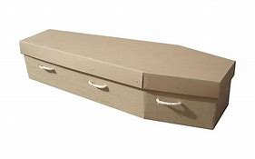
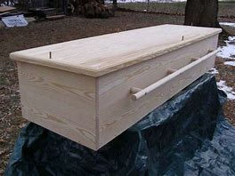
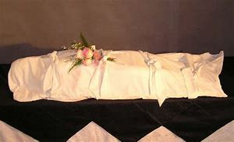
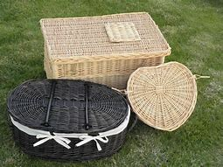
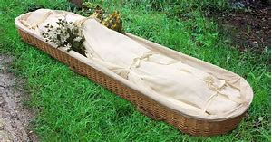
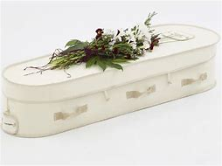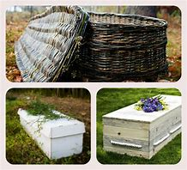

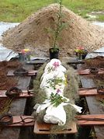
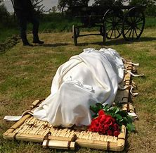
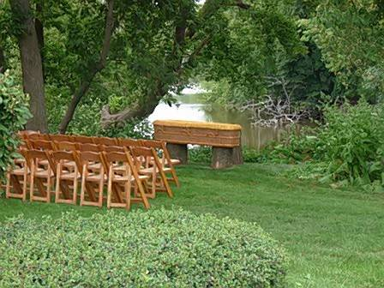
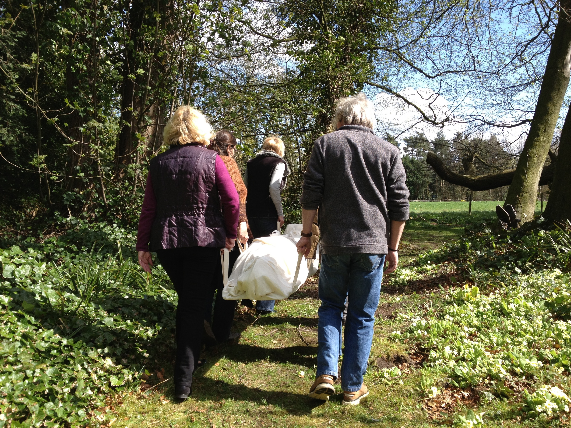
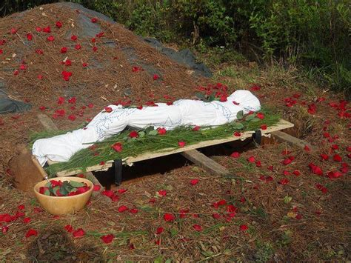
By taking responsibility for your life now, means your end-of-life is less challenging. You can embark on living fully until you die……Death is not the enemy, not living life is

This booklet can be separated into 3 double sided pages regarding you.

Legal Medical & Funeral Preferences

This double-sided insert form re your legal wishes can be separate from
the other 2 pages, photocopied, and forwarded to your chosen
solicitor separately from the rest of the booklet.
Copies should also be left with your family.

If you would like no obligation assistance with this document, contact:
LifeOptions
Death Doula’s: Denise Love deniselovelifeoptions@gmail.com

I have been a Registered Nurse for 45 years, a Palliative Care Nurse for 8 years and a Death Doula for many.

Death Doula: Denise Love deniselovelifeoptions@gmail.com
I am passionate about the way we are born, live and die
I have served many families and dying people and find it such a special time in life.
(or Nigel 03 9489 8711 or at info@ravensfunerals.com.au )
Cal/amcos licensed

